

**Abstract:**

The Binomial Option Pricing Model is a mathematical approach used to calculate the fair value of options by modeling the underlying asset's price movements in discrete steps over time. This model assumes that the asset's price can only change to two possible values in each time period, creating a binomial tree of possible future prices. By discounting the expected future payoffs, the model helps determine the option's present value and facilitates decision-making in financial markets.

***Introduction:***

Option pricing models, such as the Black-Scholes Model and Binomial Options Pricing Model, assess the theoretical value of financial options by considering factors like current stock price, strike price, time to expiration, risk-free interest rate, and volatility. These models are crucial for investors in estimating the fair market value of options and making informed decisions on buying or selling. The Black-Scholes Model, developed in the 1970s, is a foundational formula widely used for European-style options, while the Binomial Options Pricing Model is valuable for considering discrete-time movements in the market, especially for American-style options. Despite their usefulness, real-world market fluctuations and unforeseen events can cause deviations from theoretical values.

**What is an option?**

An option is a financial tool that gives you the choice to buy or sell an asset at a set price within a specific time, providing flexibility in reacting to market changes. Call options let you buy, while put options let you sell.

**Types of option:**

* Call option:
* Put Option:

**Call Option:**

A call option is a financial agreement that allows you to buy an asset at a fixed price within a certain time frame, giving you the choice to benefit if the asset's value increases. It's like having the option to purchase something at a set price later on.

**Put option:**

A put option is a financial arrangement that lets you sell an asset at a predetermined price within a specific time, offering the option to profit if the asset's value goes down. It's akin to having the choice to sell something at a fixed price in the future.

Option may also be classified according to their exercise time:

**European style option:**

A European-style option allows buying or selling an asset at a predetermined price only at the option's expiration date.

**American style option:**

An American-style option permits buying or selling an asset at a predetermined price anytime before or at the option's expiration date.

There are following model of option pricing:

**Binomial Model**

Binomial model is based on three types:

* Risk Neutral Probability Approach
* Delta-hedging/Risk-Free portfolio Approach
* Replicating portfolio Approach

In Binomial model mostly used Risk neutral probability approach.

**Binomial Model (Risk neutral probability)**:

Risk-neutral probability is an approach in finance that simplifies calculations by assuming investors are indifferent to risk, making expected returns equal to risk-free rates, simplifying option pricing models like Black-Scholes. It allows for easier valuation of options and derivatives in a theoretical, risk-neutral world.

**Binomial option pricing Model:**

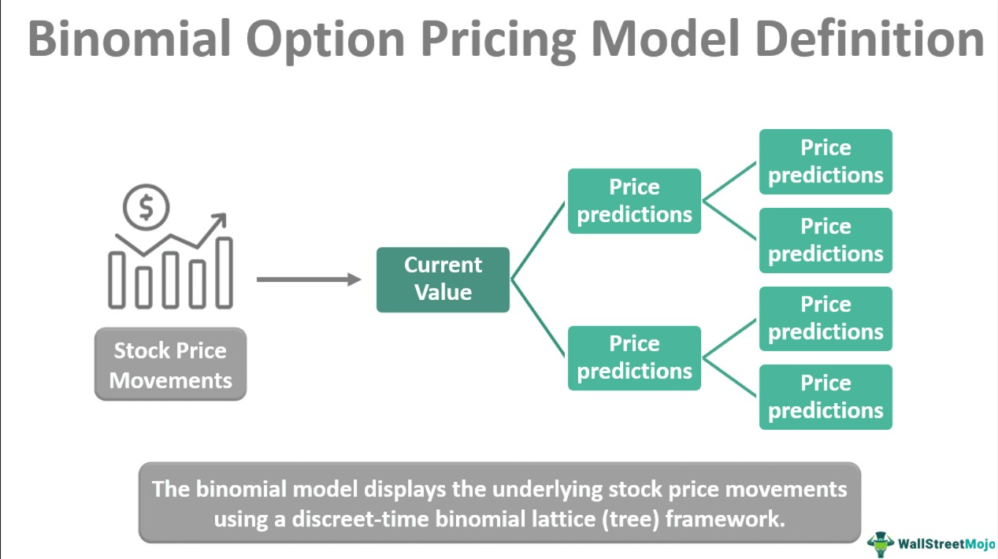

**As the name suggested, only two possible price of stock on maturity:**

* Upper Price of stock =uS
* Lower Price of stock=dS
* Current Price of stock=S
* Exercise Price Call Option/Put Option
* Risk-free rate=R

**How to calculate Risk neutral Probability?**

$$SR=\left(uS*p\right)+(dS*(1-p))$$

$$SR=(uS*p)+(dS-dS*p)$$

$$SR-dS=uS*p-dS*p$$

$$SR-dS=p\left(uS-ds\right)$$

$$p=\frac{S\left(R-d\right)}{S\left(u-d\right)}$$

So, Risk neutral free=P= $\frac{R-d}{u-d}$

**How to find the value of Option?**

$$Value of Option=\frac{\left(Cu*p\right)-\left(Cd*\left(1-p\right)\right)}{R}$$

**Option Pricing at Nodes:**

The option value at each node in the binomial tree is calculated using the risk-neutral probability and the expected future option values.

For European call option:

$$C_{n,i}=e^{-r∆t}\left(pC_{n+1,i+1}+\left(1-p\right)C_{n+1,i}\right)$$

For European Put Option:

$$P_{n,i}=e^{-r∆t}\left(pP_{n+1,i+1}+\left(1-p\right)P_{n+1,i}\right)$$

**American Option Consideration:**

For an American option, at each node, the option value is the maximum of the exercise (strike) price minus the stock price at that node and the expected future option value.

For a call option:

$$C_{n,i}=max\left(S_{n,i}-K,e^{-r∆t}\left(pC_{n+1,i+1}+\left(1-p\right)C_{n+1,i}\right)\right)$$

For a put option:

$$P_{n,i}=max\left(S_{n,i}-K,e^{-r∆t}\left(pP_{n+1,i+1}+\left(1-p\right)P_{n+1,i}\right)\right)$$

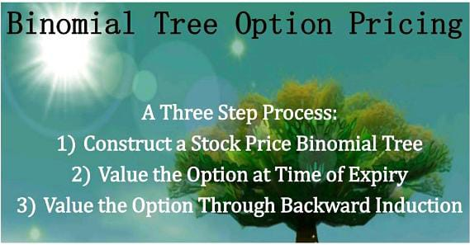

**Problem Statement:**

We have a stock whose market value is 25R.s and strike price is 25 R.s and for the duration of 2 years and Risk free return is 10% and interest rate 8% we have to calculate the price of option. we assume that it is a Risk neutral model and the prices may go up and down if it go up 10% and down 5% .

**Solution:**

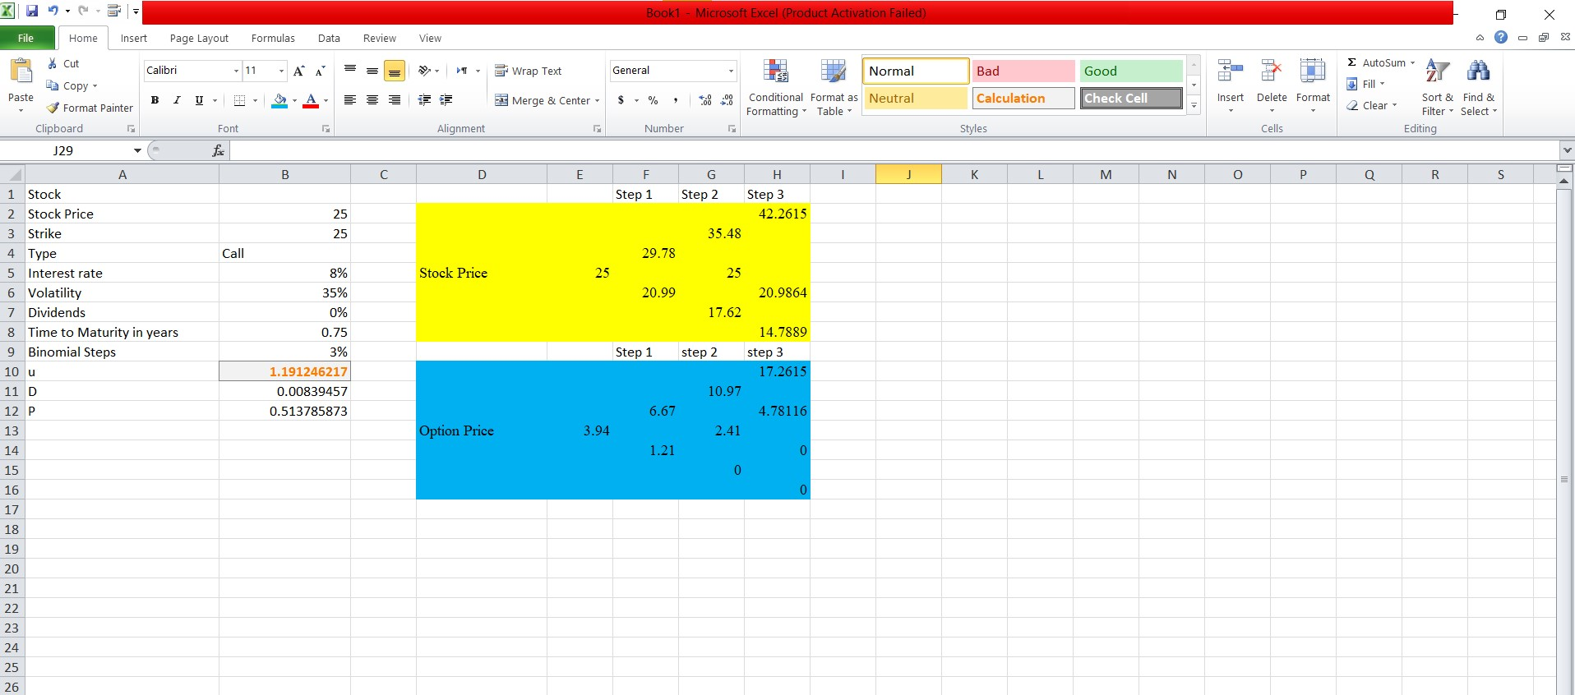**Conclusion:**

The binomial option pricing model is a valuable tool for valuing options by modeling the discrete price movements of the underlying asset. It provides a flexible and intuitive approach to estimate option prices, incorporating time, volatility, and interest rates.